
Women in the New Testament
Blessed is she who believed
Luke 1.45 (NIV UK)

Series Introduction page 2
Week 1 / 1 February Anna page 3
9 am BCP Communion
10.30 am CW Communion for Candlemas
Malachi 3.1-5
Luke 2.22-40
Week 2 / 8 February A Woman Caught in Adultery page 6
9 am BCP Communion
10.30 am Sunday Worship
Exodus 23.1-9
John 8.2-11
Week 3 / 15 February A Woman Bent Double page 9
9 am BCP Communion
10.30 am CW Communion
Exodus 20.8-11
Luke 13.10-17
Week 4 / 21 June Lydia page 11
9 am BCP Communion
10.30 CW Communion
Philippians 4.1-7
Acts 16.1-15
Week 5 / 15 November Elizabeth page 14
9 am BCP Communion
10.30 CW Communion
Malachi 4.1-6
Luke 1.5-25, 39-45
An Introduction to this series
We don’t usually write a series introduction like this, but perhaps we should from now on. There are two reasons for an introduction this time: first, this series will run through the year and interact with other series; second, more importantly, it is focussing on Women in the New Testament, and we felt the rationale deserved some attention.
There are many examples of women in the New Testament, and women feature in many different ways. We are not sure that we pay them enough attention. Sometimes they are key protagonists in God’s salvation plan. Sometimes they are unnamed but caught in a vital moment that is recorded for us. Sometimes they are characters in parables.
This series has been planned to help us consider the different ways women are portrayed in the New Testament, and how we read the accounts ourselves. Some of them are leaders in the early church, while some are suffering injustices. Some are called in extraordinary ways to witness to God’s salvation plan, while others are bystanders who recognise the timing and providence of God and praise him.
This time we have chosen to focus on a few of the real women in the New Testament and not the characters in parables. Some of them are named, but others are remembered because of their situation. We will give thanks for their stories, and ask what they teach us today.
We pray that, throughout this year which is interspersed with this five part series, you will be encouraged by the stories of these women, and the many women in the New Testament.

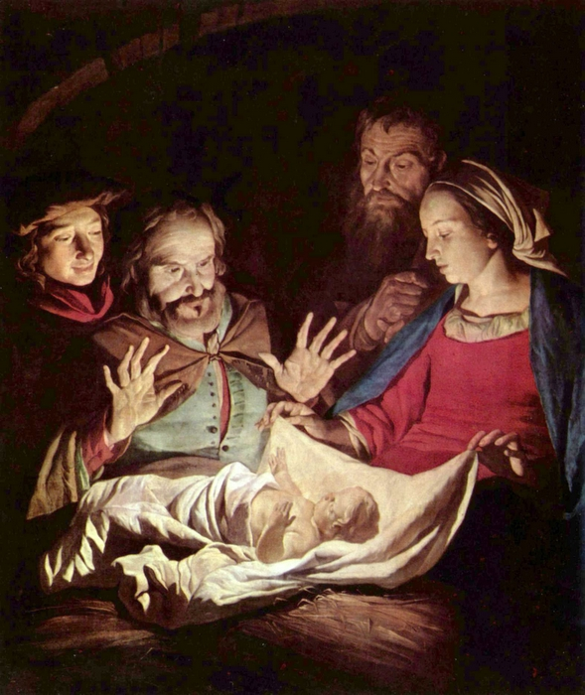
WEEK 1 / 1 February: Anna
Adoration of the Child, van Honthorst, Gerrit (1592-1656) 1621
Musée d’Arts de Nantes, Nantes, France
MALACHI 3.1-5
3 ‘I will send my messenger, who will prepare the way before me. Then suddenly the Lord you are seeking will come to his temple; the messenger of the covenant, whom you desire, will come,’ says the Lord Almighty.
² But who can endure the day of his coming? Who can stand when he appears? For he will be like a refiner’s fire or a launderer’s soap. ³ He will sit as a refiner and purifier of silver; he will purify the Levites and refine them like gold and silver. Then the Lord will have men who will bring offerings in righteousness, ⁴ and the offerings of Judah and
Jerusalem will be acceptable to the Lord, as in days gone by, as in former years.
⁵ ‘So I will come to put you on trial. I will be quick to testify against sorcerers, adulterers and perjurers, against those who defraud labourers of their wages, who oppress the widows and the fatherless, and deprive the foreigners among you of justice, but do not fear me,’ says the Lord Almighty.

LUKE 2.22-40
²² When the time came for the purification rites required by the Law of Moses, Joseph and Mary took him to Jerusalem to present him to the Lord ²³ (as it is written in the Law of the Lord, ‘Every firstborn male is to be consecrated to the Lord’), ²⁴ and to offer a sacrifice in keeping with what is said in the Law of the Lord: ‘a pair of doves or two young pigeons’.
²⁵ Now there was a man in Jerusalem called Simeon, who was righteous and devout. He was waiting for the consolation of Israel, and the Holy Spirit was on him. ²⁶ It had been revealed to him by the Holy Spirit that he would not die before he had seen the Lord’s Messiah. ²⁷ Moved by the Spirit, he went into the temple courts.
When the parents brought in the child Jesus to do for him what the custom of the Law required, ²⁸ Simeon took him in his arms and praised God, saying:

²⁹ ‘Sovereign Lord, as you have promised,
you may now dismiss your servant in peace.
³⁰ For my eyes have seen your salvation,
³¹ which you have prepared in the sight of all nations:
³² a light for revelation to the Gentiles,
and the glory of your people Israel.’
³³ The child’s father and mother marvelled at what was said about him. ³⁴ Then Simeon blessed them and said to Mary, his mother: ‘This child is destined to cause the falling and rising of many in Israel, and to be a sign that will be spoken against, ³⁵ so that the thoughts of many hearts will be revealed. And a sword will pierce your own soul too.’
³⁶ There was also a prophet, Anna, the daughter of Penuel, of the tribe of Asher. She was very old; she had lived with her husband seven years after her marriage, ³⁷ and then was a widow until she was eighty-four. She never left the temple but worshipped night and day, fasting and praying. ³⁸ Coming up to them at that very moment, she gave thanks to God and spoke about the child to all who were looking forward to the redemption of Jerusalem.
³⁹ When Joseph and Mary had done everything required by the Law of the Lord, they returned to Galilee to their own town of Nazareth. ⁴⁰ And the child grew and became strong; he was filled with wisdom, and the grace of God was on him.

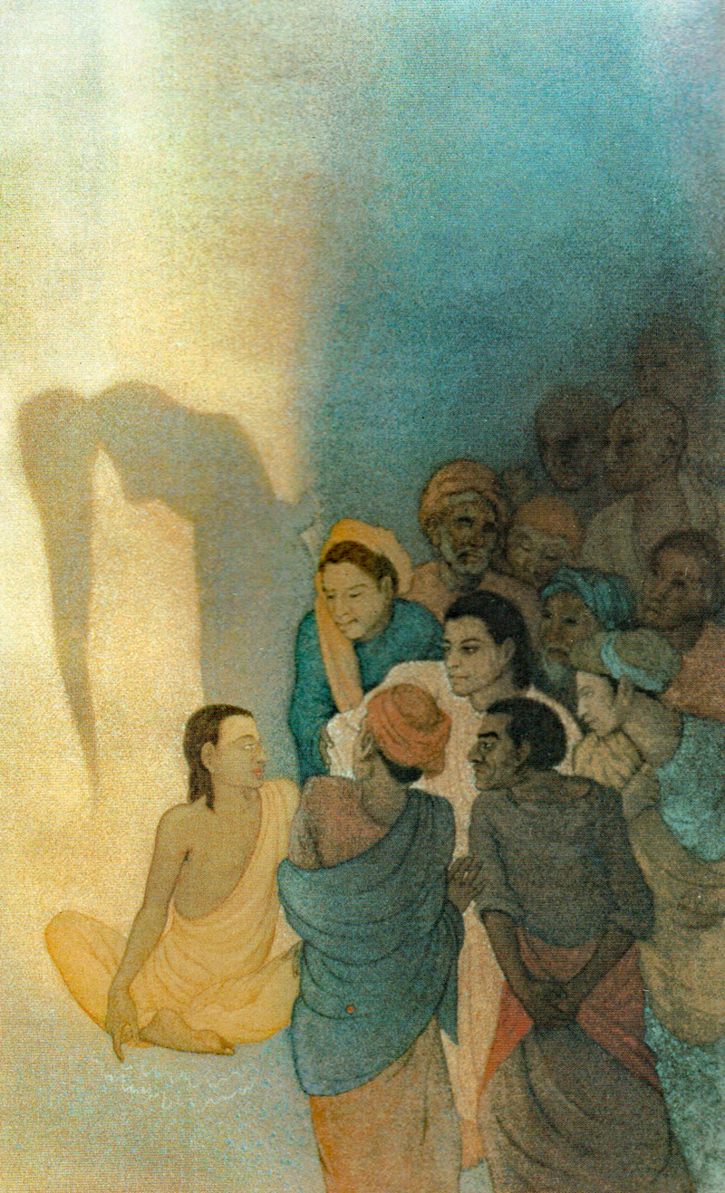
WEEK 2 / 8 February: A Woman Caught in Adultery
A Woman Taken in Adultery, Wesley, Frank (1923-2002) 1984
From Art in the Christian Tradition (online), Vanderbilt Divinity Library, Nashville, TN
EXODUS 23.1-9
23 ‘Do not spread false reports. Do not help a guilty person by being a malicious witness.
² ‘Do not follow the crowd in doing wrong. When you give testimony in a lawsuit, do not pervert justice by siding with the crowd, ³ and do not show favouritism to a poor person in a lawsuit.
⁴ ‘If you come across your enemy’s ox or donkey wandering off, be sure to return it. ⁵ If you see the donkey of someone who hates you fallen down under its load, do not leave it there; be sure you help them with it.
⁶ ‘Do not deny justice to your poor people in their lawsuits. ⁷ Have nothing to do with a false charge and do not put an innocent or honest person to death, for I will not acquit the guilty.
⁸ ‘Do not accept a bribe, for a bribe blinds those who see and twists the words of the innocent.
⁹ ‘Do not oppress a foreigner; you yourselves know how it feels to be foreigners, because you were foreigners in Egypt.

JOHN 8.2-11
² At dawn he appeared again in the temple courts, where all the people gathered round him, and he sat down to teach them. ³ The teachers of the law and the Pharisees brought in a woman caught in adultery. They made her stand before the group ⁴ and said to Jesus, ‘Teacher, this woman was caught in the act of adultery. ⁵ In the Law Moses commanded us to stone such women. Now what do you say?’ ⁶ They were using this question as a trap, in order to have a basis for accusing him.
But Jesus bent down and started to write on the ground with his finger. ⁷ When they kept on questioning him, he straightened up and said to them, ‘Let any one of you who is without sin be the first to throw a stone at her.’ ⁸ Again he stooped down and wrote on the ground.
⁹ At this, those who heard began to go away one at a time, the older ones first, until only Jesus was left, with the woman still standing there. ¹⁰ Jesus straightened up and asked her, ‘Woman, where are they? Has no one condemned you?’
¹¹ ‘No one, sir,’ she said.
‘Then neither do I condemn you,’ Jesus declared. ‘Go now and leave your life of sin.’

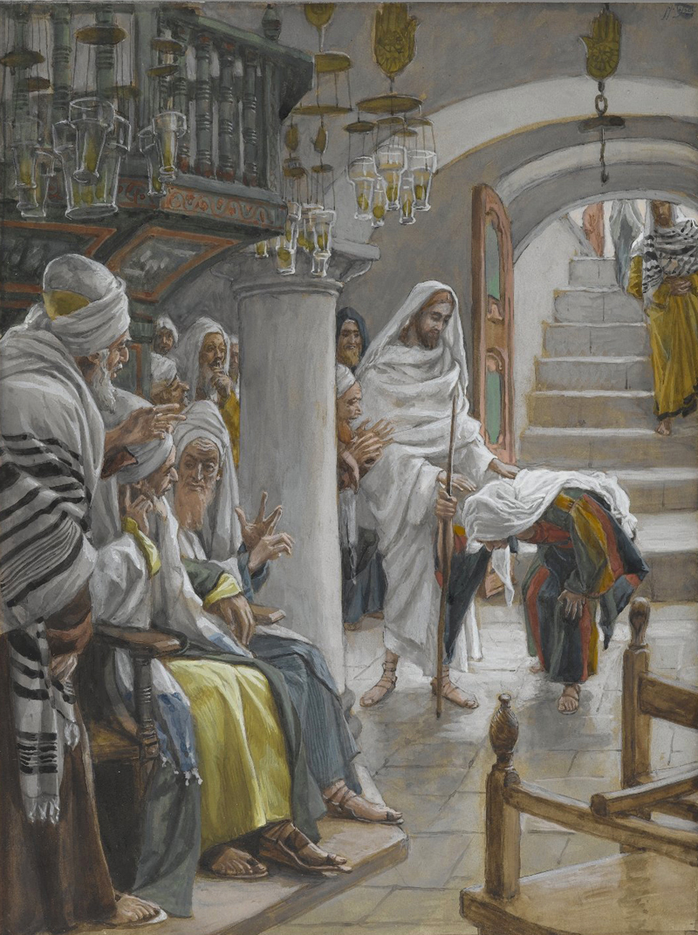
WEEK 3 / 15 February: The Woman Bent Double
Woman with an Infirmity of Eighteen Years, Tissot, James (1836-1902) c.1888-96
Brooklyn Museum, New York

EXODUS 20.8-11
⁸ ‘Remember the Sabbath day by keeping it holy. ⁹ Six days you shall labour and do all your work, ¹⁰ but the seventh day is a sabbath to the Lord your God. On it you shall not do any work, neither you, nor your son or daughter, nor your male or female servant, nor your animals, nor any foreigner residing in your towns.
¹¹ For in six days the Lord made the heavens and the earth, the sea, and all that is in them, but he rested on the seventh day. Therefore the Lord blessed the Sabbath day and made it holy.

LUKE 13.10-17
¹⁰ On a Sabbath Jesus was teaching in one of the synagogues, ¹¹ and a woman was there who had been crippled by a spirit for eighteen years. She was bent over and could not straighten up at all. ¹² When Jesus saw her, he called her forward and said to her, ‘Woman, you are set free from your infirmity.’ ¹³ Then he put his hands on her, and immediately she straightened up and praised God.
¹⁴ Indignant because Jesus had healed on the Sabbath, the synagogue leader said to the people, ‘There are six days for work. So come and be healed on those days, not on the Sabbath.’
¹⁵ The Lord answered him, ‘You hypocrites! Doesn’t each of you on the Sabbath untie your ox or donkey from the stall and lead it out to give it water? ¹⁶ Then should not this woman, a daughter of Abraham, whom Satan has kept bound for eighteen long years, be set free on the Sabbath day from what bound her?’
¹⁷ When he said this, all his opponents were humiliated, but the people were delighted with all the wonderful things he was doing.

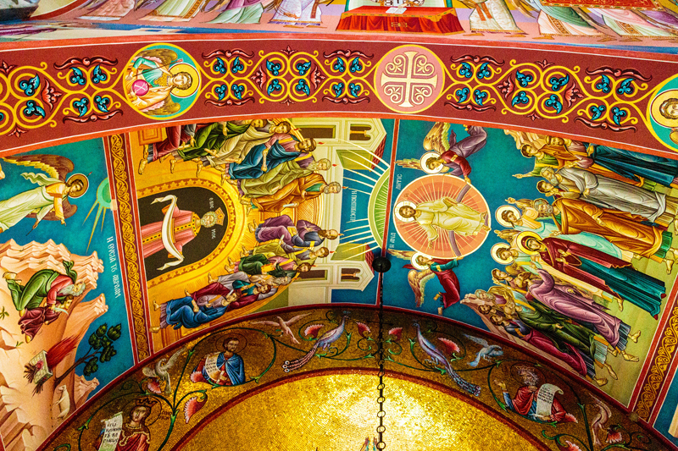
WEEK 4 / 21 June: Lydia
Lydia of Thyatira, Unknown artists 20th century
Mural in Akhisar, Turkey
PHILIPPIANS 4.1-7
4 Therefore, my brothers and sisters, you whom I love and long for, my joy and crown, stand firm in the Lord in this way, dear friends!
² I plead with Euodia and I plead with Syntyche to be of the same mind in the Lord. ³ Yes, and I ask you, my true companion, help these women since they have contended at my side in the cause of the gospel, along with Clement and the rest of my co-workers, whose names are in the book of life.
⁴ Rejoice in the Lord always. I will say it again: rejoice! ⁵ Let your gentleness be evident to all. The Lord is near. ⁶ Do not be anxious about anything, but in every situation, by prayer and petition, with thanksgiving, present your requests to God.
⁷ And the peace of God, which transcends all understanding, will guard your hearts and your minds in Christ Jesus.

ACTS 16.1-15
16 Paul came to Derbe and then to Lystra, where a disciple named Timothy lived, whose mother was Jewish and a believer but whose father was a Greek. ² The believers at Lystra and Iconium spoke well of him. ³ Paul wanted to take him along on the journey, so he circumcised him because of the Jews who lived in that area, for they all knew that his father was a Greek. ⁴ As they travelled from town to town, they delivered the decisions reached by the apostles and elders in Jerusalem for the people to obey. ⁵ So the churches were strengthened in the faith and grew daily in numbers.
⁶ Paul and his companions travelled throughout the region of Phrygia and Galatia, having been kept by the Holy Spirit from preaching the word in the province of Asia. ⁷ When they came to the border of Mysia, they tried to enter Bithynia, but the Spirit of Jesus would not allow them to. ⁸ So they passed by Mysia and went down to Troas. ⁹ During the night Paul had a vision of a man of Macedonia standing and begging him, ‘Come over to Macedonia and help us.’ ¹⁰ After Paul had seen the vision, we got ready at once to leave for Macedonia, concluding that God had called us to preach the gospel to them.
¹¹ From Troas we put out to sea and sailed straight for Samothrace, and the next day we went on to Neapolis. ¹² From there we travelled to Philippi, a Roman colony and the leading city of that district^{[a]} of Macedonia. And we stayed there several days.
¹³ On the Sabbath we went outside the city gate to the river, where we expected to find a place of prayer. We sat down and began to speak to the women who had gathered there. ¹⁴ One of those listening was a woman from the city of Thyatira named Lydia, a dealer in purple cloth. She was a worshipper of God. The Lord opened her heart to respond to Paul’s message. ¹⁵ When she and the members of her household were baptised, she invited us to her home. ‘If you consider me a believer in the Lord,’ she said, ‘come and stay at my house.’ And she persuaded us.

WEEK 5 / 15 November: Elizabeth
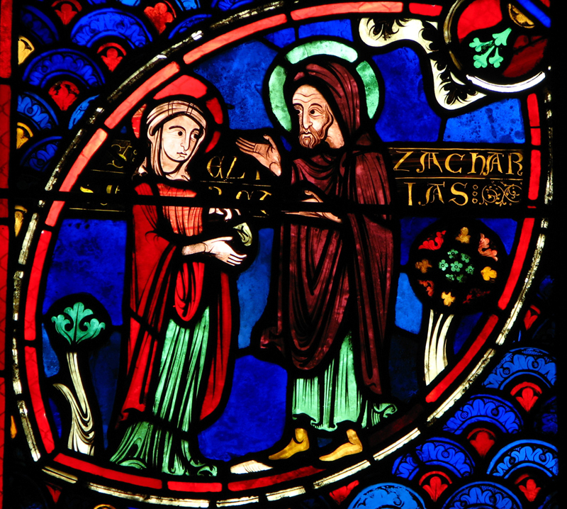
Elizabeth and Zechariah, Unknown artist 1214
Cathédrale Saint-Etienne de Bourges, Bourges, France
MALACHI 4.1-6
4 ‘Surely the day is coming; it will burn like a furnace. All the arrogant and every evildoer will be stubble, and that day that is coming will set them on fire,’ says the Lord Almighty. ‘Not a root or a branch will be left to them. ² But for you who revere my name, the sun of righteousness will rise with healing in its rays. And you will go out and frolic like well-fed calves. ³ Then you will trample on the wicked; they will be ashes under the soles of your feet on the day when I act,’ says the Lord Almighty.

⁴ ‘Remember the law of my servant Moses, the decrees and laws I gave him at Horeb for all Israel.
⁵ ‘See, I will send the prophet Elijah to you before that great and dreadful day of the Lord comes. ⁶ He will turn the hearts of the parents to their children, and the hearts of the children to their parents; or else I will come and strike the land with total destruction.’

LUKE 1.5-25
⁵ In the time of Herod king of Judea there was a priest named Zechariah, who belonged to the priestly division of Abijah; his wife Elizabeth was also a descendant of Aaron. ⁶ Both of them were righteous in the sight of God, observing all the Lord’s commands and decrees blamelessly. ⁷ But they were childless because Elizabeth was not able to conceive, and they were both very old.
⁸ Once when Zechariah’s division was on duty and he was serving as priest before God, ⁹ he was chosen by lot, according to the custom of the priesthood, to go into the temple of the Lord and burn incense. ¹⁰ And when the time for the burning of incense came, all the assembled worshippers were praying outside.
¹¹ Then an angel of the Lord appeared to him, standing at the right side of the altar of incense. ¹² When Zechariah saw him, he was startled and was gripped with fear. ¹³ But the angel said to him: ‘Do not be afraid, Zechariah; your prayer has been heard. Your wife Elizabeth will bear you a son, and you are to call him John. ¹⁴ He will be a joy and delight to you, and many will rejoice because of his birth, ¹⁵ for he will be great in the sight of the Lord.
He is never to take wine or other fermented drink, and he will be filled with the Holy Spirit even before he is born. ¹⁶ He will bring back many of the people of Israel to the Lord their God. ¹⁷ And he will go on before the Lord, in the spirit and power of Elijah, to turn the hearts of the parents to their children and the disobedient to the wisdom of the righteous – to make ready a people prepared for the Lord.’
¹⁸ Zechariah asked the angel, ‘How can I be sure of this? I am an old man and my wife is well on in years.’
¹⁹ The angel said to him, ‘I am Gabriel. I stand in the presence of God, and I have been sent to speak to you and to tell you this good news. ²⁰ And now you will be silent and not able to speak until the day this happens, because you did not believe my words, which will come true at their appointed time.’
²¹ Meanwhile, the people were waiting for Zechariah and wondering why he stayed so long in the temple. ²² When he came out, he could not speak to them. They realised he had seen a vision in the temple, for he kept making signs to them but remained unable to speak.
²³ When his time of service was completed, he returned home. ²⁴ After this his wife Elizabeth became pregnant and for five months remained in seclusion. ²⁵ ‘The Lord has done this for me,’ she said. ‘In these days he has shown his favour and taken away my disgrace among the people.’
Five different ways to give and support St Andrew’s Church:

- use our card reader
- cash
- cheque to Stapleford PCC
- as a one-off through our website standrewstapleford.org/giving
- by setting up a regular donation through the Parish Giving Scheme -
see standrewstapleford.org/giving for details

