
Epiphany according
to Matthew
Follow Me
Ephesians 3.14-5.30 (NIV UK)

Week 1 / 4 January page 2
9 am BCP Communion
10.30 am CW Communion for the Feast of Epiphany
Isaiah 60.1-6
Matthew 2.1-12 Gifts for a King, a Priest, and a Death
Week 2 / 11 January page 5
9 am BCP Communion
10.30 am Sunday Worship on the Baptism of Christ
Isaiah 42.1-9
Matthew 3.13-17 The Baptism of Christ
Week 3 / 18 January page 8
9 am BCP Communion
10.30 am CW Communion
Isaiah 49.1-7
Matthew 4.1-11 Temptation in the Desert
Week 4 / 25 January page 10
9 am BCP Communion
10.30 am All Age & Family Service
Isaiah 9.1-4
Matthew 4.12-25 Follow Me

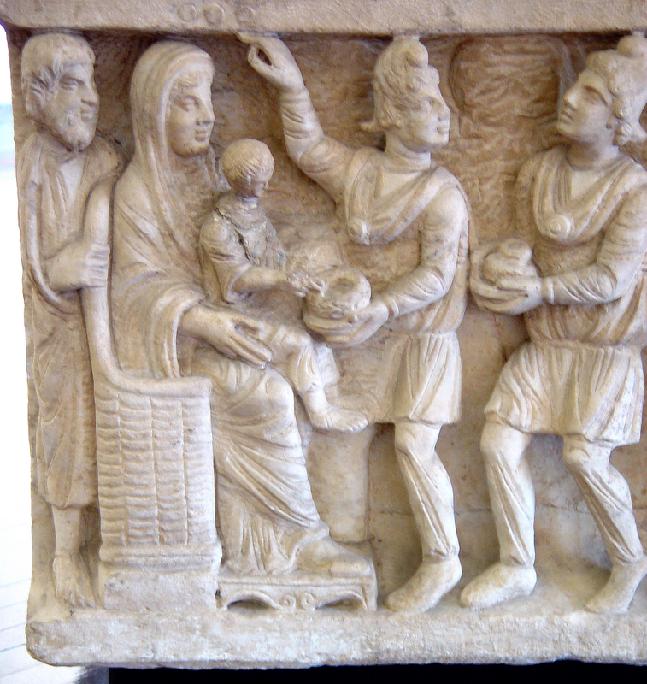
Week 1 / 4 January: Gifts for a King, a Priest, and a Death
Adoration of the Child; Arrival of the Magi, 4th Century
Dogmatic Sarcophagus, Vatican City
ISAIAH 60.1-6
60 ‘Arise, shine, for your light has come,
and the glory of the Lord rises upon you.
² See, darkness covers the earth
and thick darkness is over the peoples,
but the Lord rises upon you
and his glory appears over you.
³ Nations will come to your light,
and kings to the brightness of your dawn.
⁴ ‘Lift up your eyes and look about you:
all assemble and come to you;
your sons come from afar,
and your daughters are carried on the hip.
⁵ Then you will look and be radiant,
your heart will throb and swell with joy;
the wealth on the seas will be brought to you,
to you the riches of the nations will come.
⁶ Herds of camels will cover your land,
young camels of Midian and Ephah.
And all from Sheba will come,
bearing gold and incense
and proclaiming the praise of the Lord.

MATTHEW 2.1-12
2 After Jesus was born in Bethlehem in Judea, during the time of King Herod, Magi from the east came to Jerusalem ² and asked, ‘Where is the one who has been born king of the Jews? We saw his star when it rose and have come to worship him.’
³ When King Herod heard this he was disturbed, and all Jerusalem with him. ⁴ When he had called together all the people’s chief priests and teachers of the law, he asked them where the Messiah was to be born. ⁵ ‘In Bethlehem in Judea,’ they replied, ‘for this is what the prophet has written:
⁶ ‘“But you, Bethlehem, in the land of Judah,
are by no means least among the rulers of Judah;
for out of you will come a ruler
who will shepherd my people Israel.”

⁷ Then Herod called the Magi secretly and found out from them the exact time the star had appeared. ⁸ He sent them to Bethlehem and said, ‘Go and search carefully for the child. As soon as you find him, report to me, so that I too may go and worship him.’
⁹ After they had heard the king, they went on their way, and the star they had seen when it rose went ahead of them until it stopped over the place where the child was. ¹⁰ When they saw the star, they were overjoyed. ¹¹ On coming to the house, they saw the child with his mother Mary, and they bowed down and worshipped him. Then they opened their treasures and presented him with gifts of gold, frankincense and myrrh. ¹² And having been warned in a dream not to go back to Herod, they returned to their country by another route.

WEEK 2 / 11 January: The Baptism of Christ
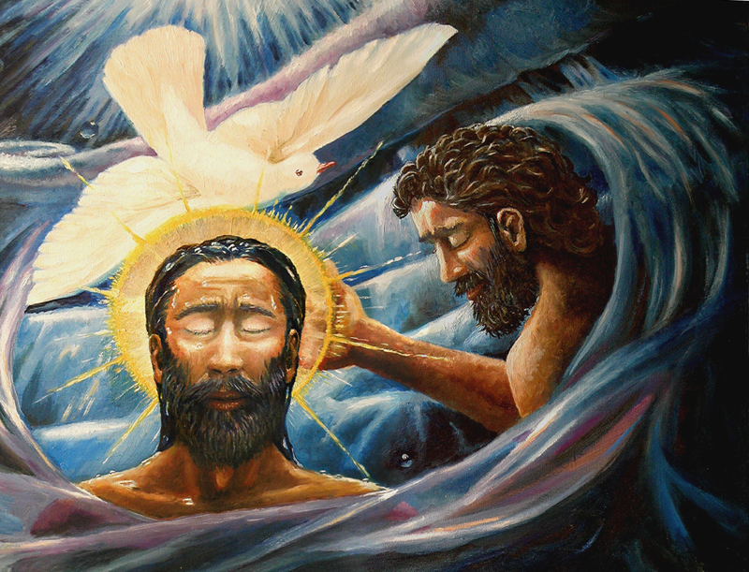
Baptism of Christ – Zelenka, Dave
Painting, from Art in the Christian Tradition (online), Vanderbilt Divinity Library, Nashville, TN
ISAIAH 42.1-9
42 ‘Here is my servant, whom I uphold,
my chosen one in whom I delight;
I will put my Spirit on him,
and he will bring justice to the nations.
² He will not shout or cry out,
or raise his voice in the streets.
³ A bruised reed he will not break,
and a smouldering wick he will not snuff out.
In faithfulness he will bring forth justice;
⁴ he will not falter or be discouraged
till he establishes justice on earth.
In his teaching the islands will put their hope.’

⁵ This is what God the Lord says –
the Creator of the heavens, who stretches them out,
who spreads out the earth with all that springs from it,
who gives breath to its people,
and life to those who walk on it:
⁶ ‘I, the Lord, have called you in righteousness;
I will take hold of your hand.
I will keep you and will make you
to be a covenant for the people
and a light for the Gentiles,
⁷ to open eyes that are blind,
to free captives from prison
and to release from the dungeon those who sit in darkness.
⁸ ‘I am the Lord; that is my name!
I will not yield my glory to another
or my praise to idols.
⁹ See, the former things have taken place,
and new things I declare;
before they spring into being
I announce them to you.’

MATTHEW.3:13-17
¹³ Then Jesus came from Galilee to the Jordan to be baptised by John. ¹⁴ But John tried to deter him, saying, ‘I need to be baptised by you, and do you come to me?’
¹⁵ Jesus replied, ‘Let it be so now; it is proper for us to do this to fulfil all righteousness.’ Then John consented.
¹⁶ As soon as Jesus was baptised, he went up out of the water. At that moment heaven was opened, and he saw the Spirit of God descending like a dove and alighting on him. ¹⁷ And a voice from heaven said, ‘This is my Son, whom I love; with him I am well pleased.’

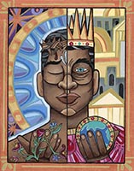
WEEK 3 / 18 January: Temptation in the Desert
A Choice – Pittman, Lauren Wright, 2018
Painting, from Art in the Christian Tradition (online), Vanderbilt Divinity Library, Nashville, TN

ISAIAH 49.1-7
49 Listen to me, you islands;
hear this, you distant nations:
before I was born the Lord called me;
from my mother’s womb he has spoken my name.
² He made my mouth like a sharpened sword,
in the shadow of his hand he hid me;
he made me into a polished arrow
and concealed me in his quiver.
³ He said to me, ‘You are my servant,
Israel, in whom I will display my splendour.’
⁴ But I said, ‘I have laboured in vain;
I have spent my strength for nothing at all.
Yet what is due to me is in the Lord’s hand,
and my reward is with my God.’

⁵ And now the Lord says –
he who formed me in the womb to be his servant
to bring Jacob back to him
and gather Israel to himself,
for I am honoured in the eyes of the Lord
and my God has been my strength –
⁶ he says:
‘It is too small a thing for you to be my servant
to restore the tribes of Jacob
and bring back those of Israel I have kept.
I will also make you a light for the Gentiles,
that my salvation may reach to the ends of the earth.’
⁷ This is what the Lord says –
the Redeemer and Holy One of Israel –
to him who was despised and abhorred by the nation,
to the servant of rulers:
‘Kings will see you and stand up,
princes will see and bow down,
because of the Lord, who is faithful,
the Holy One of Israel, who has chosen you.’

MATTHEW 4.1-11
4 Then Jesus was led by the Spirit into the wilderness to be tempted by the devil. ² After fasting for forty days and forty nights, he was hungry. ³ The tempter came to him and said, ‘If you are the Son of God, tell these stones to become bread.’
⁴ Jesus answered, ‘It is written: “Man shall not live on bread alone, but on every word that comes from the mouth of God.”
⁵ Then the devil took him to the holy city and set him on the highest point of the temple. ⁶ ‘If you are the Son of God,’ he said, ‘throw yourself down. For it is written:
‘“He will command his angels concerning you,
and they will lift you up in their hands,
so that you will not strike your foot against a stone.
⁷ Jesus answered him, ‘It is also written: “Do not put the Lord your God to the test.
⁸ Again, the devil took him to a very high mountain and showed him all the kingdoms of the world and their splendour. ⁹ ‘All this I will give you,’ he said, ‘if you will bow down and worship me.’
¹⁰ Jesus said to him, ‘Away from me, Satan! For it is written: “Worship the Lord your God, and serve him only.”
¹¹ Then the devil left him, and angels came and attended him.

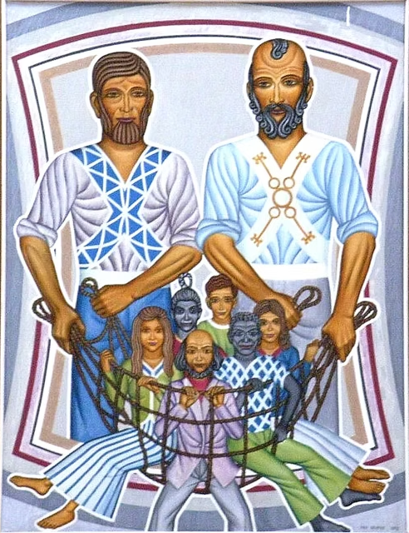
WEEK 4 / 25 January: Follow Me
St Peter and St Andrew – ca. 20th C, Koenig, Peter Winifried (Canisius)
St Andrew’s, Chippenham
ISAIAH 9.1-4
9 Nevertheless, there will be no more gloom for those who were in distress. In the past he humbled the land of Zebulun and the land of Naphtali, but in the future he will honour Galilee of the nations, by the Way of the Sea, beyond the Jordan –
² The people walking in darkness
have seen a great light;
on those living in the land of deep darkness
a light has dawned.
³ You have enlarged the nation
and increased their joy;
they rejoice before you
as people rejoice at the harvest,
as warriors rejoice
when dividing the plunder.
⁴ For as in the day of Midian’s defeat,
you have shattered
the yoke that burdens them,
the bar across their shoulders,
the rod of their oppressor.

MATTHEW 4.12-25
¹² When Jesus heard that John had been put in prison, he withdrew to Galilee. ¹³ Leaving Nazareth, he went and lived in Capernaum, which was by the lake in the area of Zebulun and Naphtali – ¹⁴ to fulfil what was said through the prophet Isaiah:
¹⁵ ‘Land of Zebulun and land of Naphtali,
the Way of the Sea, beyond the Jordan,
Galilee of the Gentiles –
¹⁶ the people living in darkness
have seen a great light;
on those living in the land of the shadow of death
a light has dawned.’
¹⁷ From that time on Jesus began to preach, ‘Repent, for the kingdom of heaven has come near.’
¹⁸ As Jesus was walking beside the Sea of Galilee, he saw two brothers, Simon called Peter and his brother Andrew. They were casting a net into the lake, for they were fishermen. ¹⁹ ‘Come, follow me,’ Jesus said, ‘and I will send you out to fish for people.’ ²⁰ At once they left their nets and followed him.

²¹ Going on from there, he saw two other brothers, James son of Zebedee and his brother John. They were in a boat with their father Zebedee, preparing their nets. Jesus called them, ²² and immediately they left the boat and their father and followed him.
²³ Jesus went throughout Galilee, teaching in their synagogues, proclaiming the good news of the kingdom, and healing every disease and illness among the people.
²⁴ News about him spread all over Syria, and people brought to him all who were ill with various diseases, those suffering severe pain, the demon-possessed, those having seizures, and the paralysed; and he healed them. ²⁵ Large crowds from Galilee, the Decapolis, Jerusalem, Judea and the region across the Jordan followed him.

Five different ways to give and support St Andrew’s Church:

- use our card reader
- cash
- cheque to Stapleford PCC
- as a one-off through our website standrewstapleford.org/giving
- by setting up a regular donation through the Parish Giving Scheme -
see standrewstapleford.org/giving for details

