Craft Activities for Mothering Sunday 14 March 2021
1. Paper flowers for Mother’s Day
You will need: white card; tissue or coloured paper; glue; pens or crayons; glitter; clean cupcake holders 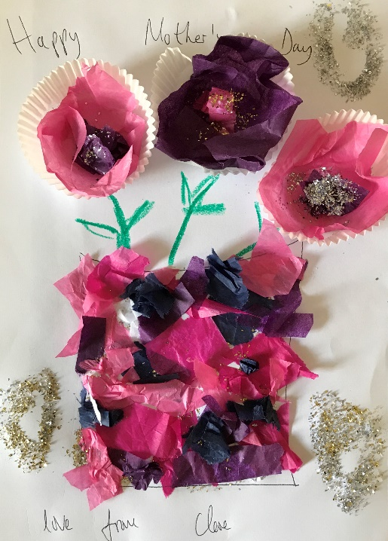
Method:
- Glue two to three cupcake holders onto the white piece of card
- Glue in several layers of coloured tissue paper or coloured paper
- Draw the stalks with your crayons
- Decorate with glitter
- Add your own message!
2. Origami hearts
You will need:
- Squares of paper: coloured, patterned or plain
- Optional: pens or pencils to decorate or to write messages, safety pin to make a brooch, ribbon to make a necklace, string or wool to make a garland, sticky tape
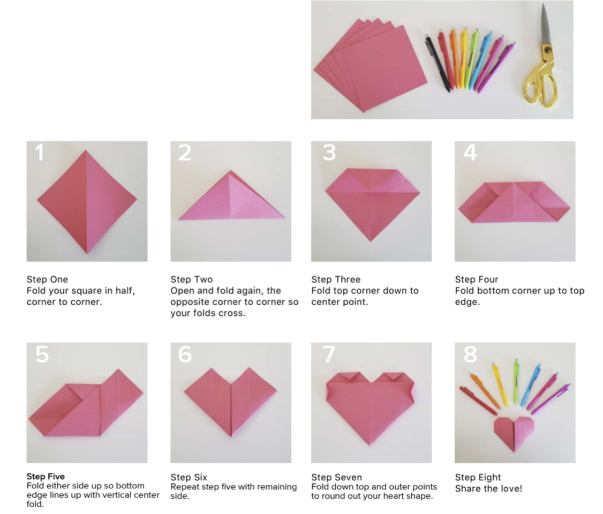

3. Heart Biscuits 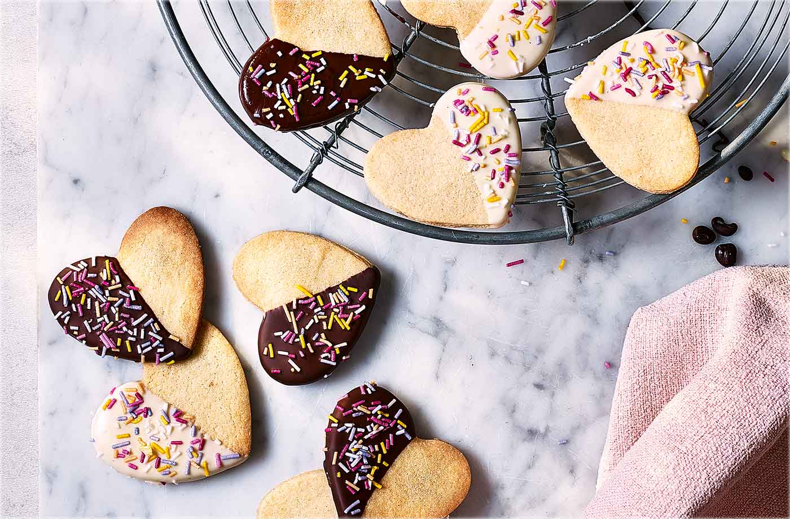

Ingredients
- 220g unsalted butter, softened
- 200g caster sugar
- 1 large egg, beaten
- 2 tsp vanilla extract
- 400g plain flour, plus extra for dusting
- 100g dark chocolate
- 100g white chocolate
- coloured strands, to decorate

Method
- Whisk the butter and sugar in a large bowl with an electric whisk for 2 mins until creamy and smooth. Add the egg and whisk until combined.
- Add the vanilla and flour and mix with a wooden spoon to form a smooth dough. Cover the bowl with clingfilm and chill for 10 mins.
- Preheat the oven to gas 4, 180°C, fan 160°C. On a lightly floured surface, roll out the dough to about 2mm thick. Cut out biscuits using a 6cm heart-shaped cookie cutter. Reroll the trimmings as necessary until the dough is used up. Place the biscuits on baking sheets lined with nonstick baking paper and bake for 12-15 mins until pale golden and turning crisp around the edges. Transfer to a wire rack and leave to cool completely.
- Melt the dark and white chocolate in separate heatproof bowls each set over a small pan of simmering water. Dip half the biscuits halfway into the dark chocolate and sprinkle the chocolate-coated side with coloured strands. Repeat with the remaining biscuits and white chocolate. Place on a wire rack to cool and set. The decorated biscuits will keep for a week in an airtight container.

Prayers including Collect and Lord’s Prayer SIMON CROCUS PRAYERS
Mothering Sunday can be hard for some folks, for all kinds of reasons. Here is an activity that combines the traditional Mother’s Day flowers with space for us to explore and acknowledge some of the other emotions that such a day may engender. We will make some simple flowers from torn paper hearts, and add them to a prayer bouquet as tokens of remembrance or thanks, of sorrow or hope, of joy or loss. The torn paper symbolises the imperfections and fragility of our human relationships, while the hearts remind us that God, who is love, is a partner in our human tragedies and joys.
You will need:
- Sheets of paper of assorted colours – each sheet makes six crocuses
- Coloured pens for writing mini prayers
- Floral foam (‘Oasis’ – dry type) carve into a hemisphere if you like
- blunt knife or toothpick
How to make Crocus Prayers
- Fold the paper in half lengthwise and then the same again, to make a long, thin strip.
- Using your fingertips, tear half a heart shape, starting and ending at the fold. You should be able to get three hearts down the strip. This will make six hearts in all.
- Add whatever words you wish.
- Fold your heart in half, so the bottom point sits level with the top curves.
- Form this into a cone with the torn edges outermost.
- To keep the cone in place, pinch the end and fold over the point.
- Make a small slit in the floral foam with a blunt knife or a toothpick, and add the crocus to the bouquet.

