Activities Sheet

Bible Story:

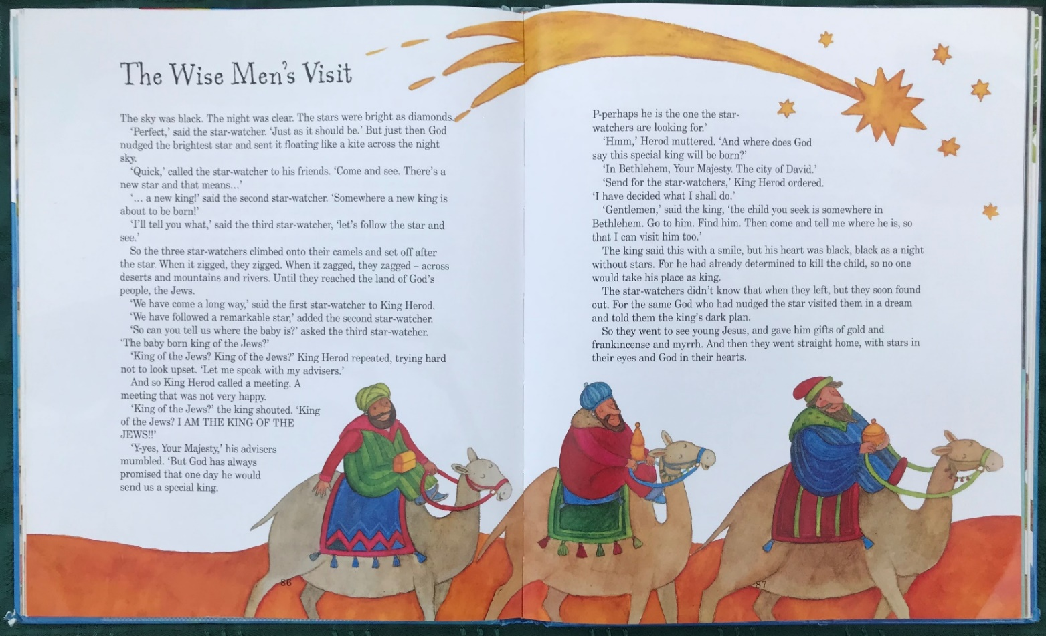
1. Crowns
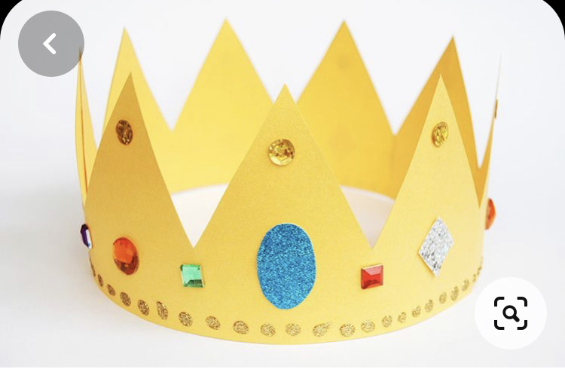
You will need: card; wrapping paper or tissue paper; sticky tape; stick on jewels etc
Method:
- Cut a long and deep strip from the card and wrap it around your head. You may have to ask an adult for help! And Cut to size.
- Cut out the crown shape then secure with sticky tape.
- Decorate with wrapping paper, scraps of tinsel, jewelled stickers shiny paper.
2. Wise Men
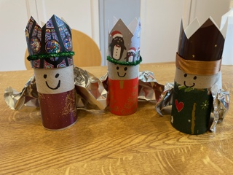
You’ll need:
3 toilet roll inners
Card for the crown, e.g., from Christmas cards
Coloured paper or fabric
Ribbon/pipe cleaners/tinsel (optional)
Shiny paper or foil for the cape
Pen
Scissors
Sticky tape

For each wiseman:
1. From a rectangle of card, cut a crown and tape it to the top of a toilet roll inner. Add ribbon or pipe cleaner or tinsel if you’d like to.
2. Cut a rectangle of coloured paper or fabric and attach to the lower end of the toilet roll inner.
3. Draw the wiseman’s face.
4. Gather one long edge of a rectangle of aluminium foil or shiny paper and stick to the back of the wiseman to form a cape.

3. Star Cupcakes
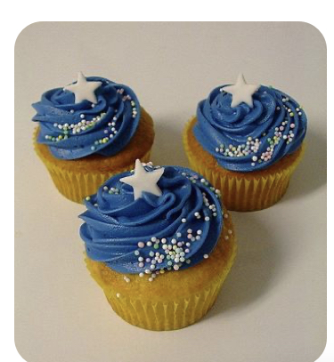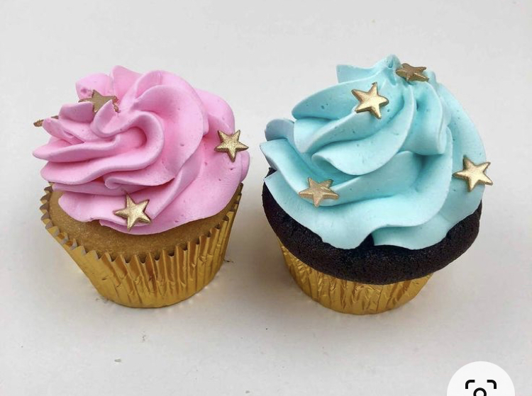

Recipe from BBC Good Food

Ingredients
- 110g softened butter
- 110g golden caster sugar
- 2 large eggs
- ½ tsp vanilla extract
- 110g self-raising flour

For the buttercream
- 150g softened butter
- 300g icing sugar
- 1 tsp vanilla extract
- 3 tbsp milk
- food colouring paste of your choice (optional)
- star sprinkles or shapes to decorate

Method
- STEP 1
Heat oven to 180C/160C fan/gas 4 and fill a 12 cupcake tray with cases.
- STEP 2
Using an electric whisk beat 110g softened butter and 110g golden caster sugar together until pale and fluffy then whisk in 2 large eggs, one at a time, scraping down the sides of the bowl after each addition.
- STEP 3
Add ½ tsp vanilla extract, 110g self-raising flour and a pinch of salt, whisk until just combined then spoon the mixture into the cupcake cases.
- STEP 4
Bake for 15 mins until golden brown and a skewer inserted into the middle of each cake comes out clean. Leave to cool completely on a wire rack.
- STEP 5
To make the buttercream, whisk 150g softened butter until super soft then add 300g icing sugar, 1 tsp vanilla extract and a pinch of salt.
- STEP 6
Whisk together until smooth (start off slowly to avoid an icing sugar cloud) then beat in 3 tbsp milk.
- STEP 7
If wanting to colour, stir in the food colouring now. Spoon or pipe onto the cooled cupcakes. Add star sprinkles!

Epiphany Star finger print prayers
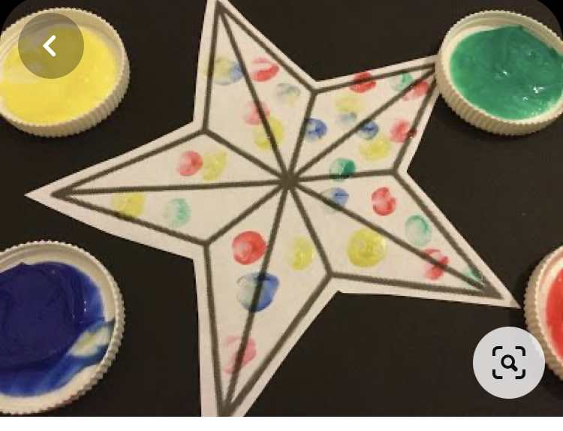
You will need: White card; pens; finger paints
Method:
- Draw a large star shape on your piece of card, and then cut it out.
- Dip your finger into the paint. As you pray, place a finger print on your star as a symbol of your prayer.
- Finish with the Lord’s prayer

