In the name of Jesus

Bible story
Matthew 10.40-42
Jesus said to his disciples, "Wherever you go, if people welcome you, then they are welcoming me, too. And if they welcome me, then they are also welcoming God."
He continued, "If someone welcomes a prophet and welcomes them because they are a prophet, then they will receive the same reward as a prophet. If someone welcomes a good person and welcomes them because they are good, then they will receive the same reward as a good person.
And if someone helps one of these little ones – if they give them only a cup of cold water because they are one of my followers – then they will certainly be rewarded."

Talk together with children
- What does it mean to welcome someone?
- How do you welcome someone who comes to your home?
- What might you be able to do to offer a welcome to someone
at home, school or church?
- How does it feel to be more valuable than sparrows?
- Do the challenges in this passage outweigh the promises Jesus makes?
- What does the passage tell us about being disciples of Jesus?

Craft

Welcome card
Design a simple card to give to welcome somebody who is new to your church.
You will need: a card for each child (template), crayons and pens or pencils; collage materials.
- Take a card template, and fold it in half. Decorate the front door on the card to make it look welcoming and attractive.
- Write a message of welcome inside the card for someone who is new to your church.
- You might like to keep the cards to have them ready to give to new people who come to your church.

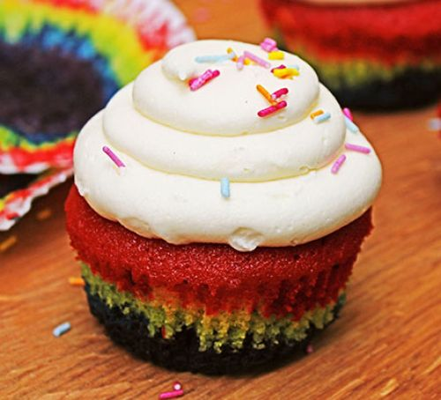

Rainbow cupcakes
BBC Good food Magazine
Prep: 25 mins Cook: 25 mins plus cooling
Makes 10

Ingredients
- 110g unsalted butter, softened
- ½ tsp vanilla extract
- 110g caster sugar
- 2 large eggs
- 110g self-raising flour
- red, blue and yellow gel food colouring
- sprinkles (optional)

For the buttercream
- 150g butter , softened
- 300g icing sugar
- 3 tbsp milk
Method
- Heat the oven to 180C/160C fan/gas 4 and fill a cupcake tray with 10 cases.
- Beat the butter, vanilla and caster sugar together with an electric whisk until pale and fluffy. Gradually whisk in the eggs, scraping down the sides of the bowl after each addition.
- Mix in the flour and a pinch of salt until just combined. Divide into five bowls and colour each a different shade with a drop of food colouring. We chose red, yellow, green, blue and purple.
- Starting with the end of the rainbow (in our case purple), evenly spread 1 tsp of the mixture into each cupcake case using a piping bag or the back of a teaspoon. Top with 1 tsp of the next colour and spread – be careful not to mix the colours together whilst bringing the mix all the way to the edge of the case. Repeat until all the colours are used up and you’re left with an even layer of red on the top.
- Bake for 15 mins, until a skewer inserted into the middle of each cake comes out clean. Leave to cool completely on a wire rack.
- To make the buttercream, beat the butter until very soft. Add the icing sugar, vanilla extract and a pinch of salt and whisk together until smooth (start off slowly to avoid an icing sugar cloud). Beat in the milk until combined.
- Pipe the buttercream on top of the cupcakes using a circular nozzle, or spread on with a palette knife. Top with sprinkles, if you like.
- Share with friends, neighbours or someone new!

Prayers: Tower of blessings

A prayer activity to ask for God’s blessing on people
You will need: Duplo or Lego blocks and sticky labels/small pieces of paper and sticky tac, pens.
Write on labels the names of people they would like God to bless and stick each name onto a Lego block. Alternatively, write names on paper ‘bricks’ to stick on a wall.
Build a tower with the blocks. Each time someone adds a block to the tower, ask God to bless that person.
Stand around the completed tower and say together, ‘Lord, bless these people. Amen.’
Prayer:
Father God, we are welcomed in the name of Jesus.
Help us to welcome others in your name
so that we all join together as your family. Amen.

Song God on earth: John Bryden

When God Almighty came to earth
He took the pain of Jesus’ birth,
He took the flight of refugee,
And whispered, “Humbly follow me.”

When God Almighty went to work,
Carpenter’s sweat he didn’t shirk,
Profit and loss he didn’t flee,
And whispered, “Humbly follow me.”

When God Almighty walked the street,
The critic’s curse he had to meet,
The cynic’s smile he had to see,
And whispered, “Humbly follow me.”

When God Almighty comes again,
He’ll meet us incognito as then;
And though no words may voice his plea,
He’ll whisper, “Are you following me?”

Sing and listen
The welcome song on Absolute modern worship for kids volume 3
Jesus’ hands were kind hands, doing good to all
Ask seek knock, Hillsong Kids on Can you believe it?
Heaven is our home, Hillsong Kids on Can you believe it?
Come, now is the time to worship
Better is one day, Kutless on Christian music’s best – worship
All are welcome, Marty Haugen on All are welcome
Love is here, Tenth avenue north on Over and underneath
See also Same Boat @ HOME

Live your faith
Try and smile at everyone you meet this week!

Activity Sheet English

Colouring Sheet English

