Messy Church 16 August 2020

Living Water

Activities Sheet

Song: Guide me O thou great Redeemer

Guide me o thou great redeemer,
Pilgrim through this barren land.
I am weak but thou art mighty,
Hold me with thy powerful hand.
Bread of heaven, bread of heaven,
Feed me now and evermore,
Feed me now and evermore.

Open now the crystal fountain,
Whence the healing stream doth flow.
Let the fiery cloudy pillar
Lead me all my journey through.
Strong deliverer, strong deliverer,
Be thou still my strength and shield,
Be thou still my strength and shield.

When I tread the verge of Jordan,
Bid my anxious fears sub-side.
Death of death and hell’s destruction,
Land me safe on Canaan’s side.
Songs and praises, songs and praises,
I will ever give to thee,
I will ever give to thee.

Bible Story John 4: 1-14; 25-26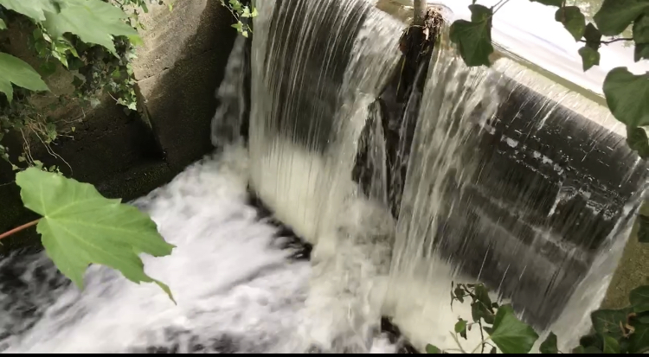

Now Jesus learned that the Pharisees had heard that he was gaining and baptizing more disciples than John— ² although in fact it was not Jesus who baptized, but his disciples. ³ So he left Judea and went back once more to Galilee.
⁴ Now he had to go through Samaria. ⁵ So he came to a town in Samaria called Sychar, near the plot of ground Jacob had given to his son Joseph. ⁶ Jacob’s well was there, and Jesus, tired as he was from the journey, sat down by the well. It was about noon.
⁷ When a Samaritan woman came to draw water, Jesus said to her, “Will you give me a drink?” ⁸ (His disciples had gone into the town to buy food.)
⁹ The Samaritan woman said to him, “You are a Jew and I am a Samaritan woman. How can you ask me for a drink?” (For Jews do not associate with Samaritans.^{[a]})
¹⁰ Jesus answered her, “If you knew the gift of God and who it is that asks you for a drink, you would have asked him and he would have given you living water.”
¹¹ “Sir,” the woman said, “you have nothing to draw with and the well is deep. Where can you get this living water? ¹² Are you greater than our father Jacob, who gave us the well and drank from it himself, as did also his sons and his livestock?”
¹³ Jesus answered, “Everyone who drinks this water will be thirsty again, ¹⁴ but whoever drinks the water I give them will never thirst. Indeed, the water I give them will become in them a spring of water welling up to eternal life.”
¹⁵ The woman said to him, “Sir, give me this water so that I won’t get thirsty and have to keep coming here to draw water.” ………²⁵ The woman said, “I know that Messiah” (called Christ) “is coming. When he comes, he will explain everything to us.”
²⁶ Then Jesus declared, “I, the one speaking to you—I am he.”

Craft

1.God creates water (Genesis 1). Holy Spirit Hovercrafts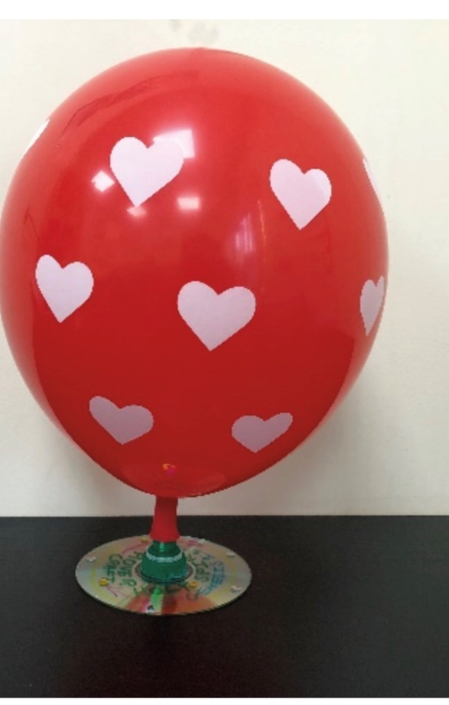
You will need: sports cap bottle lids, such as those used on Fruit Shoots; blank CD/DVDs; balloons; superglue; glue sticks; sequins; marker pens
Method:
- Beforehand, glue the bottle lids to the CDs. To do this, remove the sports-cap lid from the bottle and push it down so it is closed. Glue the lid to the centre of the underside of the disk around the hole, and leave it to dry overnight.
- Decorate the underside of the disk and/or write the words ‘Holy Spirit hovercraft’.
- Once complete, blow up a balloon and attach the end to the lid. Put the lid in the open position, and watch it glide over a flat surface.

2. God moves the water (Exodus). Parting of the Red (pepper) Sea
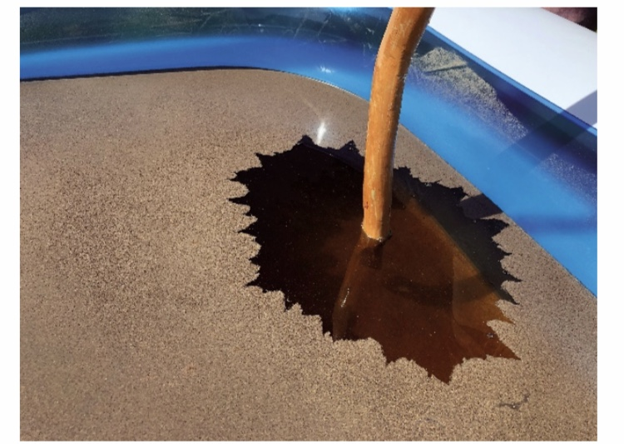
You will need: a rectangular paddling pool or a washing-up bowl; water; dishwashing soap; large towels; a large staff/stick; ground black pepper

Method:
- Fill the paddling pool or washing-up bowl with water, and then pour the pepper over the water.
- Put some soap on your finger or the staff/stick and put it in the water. The pepper will move as it reacts with the soap!

3. God walks on water (Matthew). Apple Boats
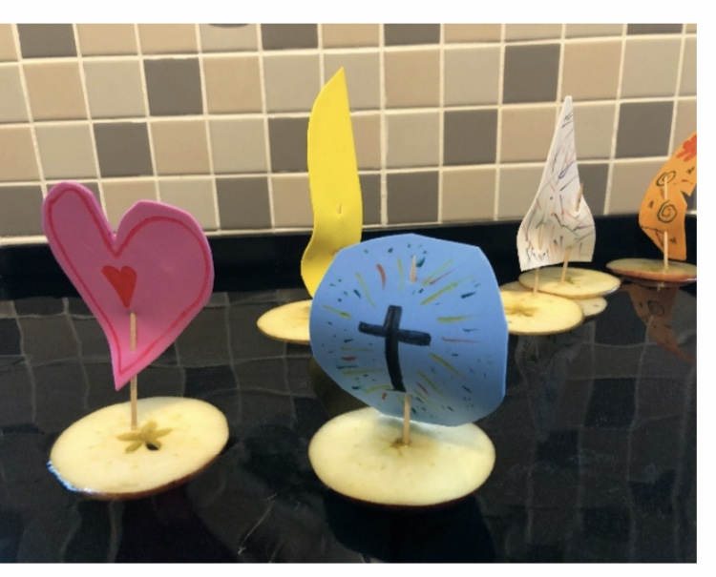
You will need: apples; cocktail sticks; felt-tip pens; coloured foam sheets or paper; a water tray (filled with water); a knife (to cut the apples); jelly babies

Method:
- Thinly slice the apples in round pieces.
- Cut a wind sail shape out of the foam and decorate it.
- Attach the foam sail to the cocktail stick and stick it into the centre of the apple slice.
- Add Jelly babies to your boat.
- Float the boat on the water and splash gently to simulate the sea.
- Can your jelly baby walk on water?!

Prayers: Water of Life
You will need: A large bowl, two smaller bowls of water, small cups, the two prayers below and any of your own you may wish to add.
“I will pour water onto the thirsty land”(Isaiah 44:3)
As you pray,
- Take a small cup and fill it from one of the smaller bowls
- Slowly pour the water into the large bowl, saying the prayer as you do so
Prayer 1: Spirit of God, as we pour this water please fill all the children in our home / church / community. Amen
Prayer 2: Father God, refresh all children and give them new life and a new love for you. Amen

