Peter the rock

Bible story Matthew 16:13-20 (Good News Translation)
¹³ Jesus went to the territory near the town of Caesarea Philippi, where he asked his disciples, “Who do people say the Son of Man is?”
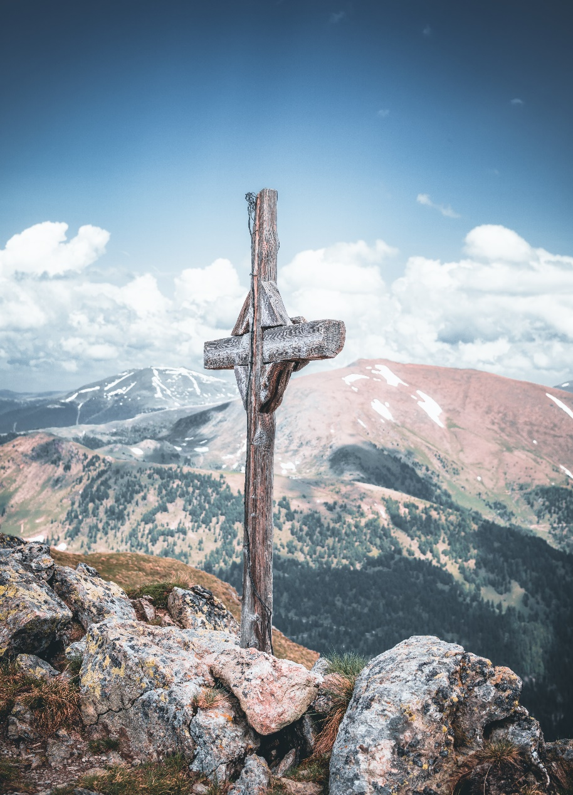
¹⁴ “Some say John the Baptist,” they answered. “Others say Elijah, while others say Jeremiah or some other prophet.”
¹⁵ “What about you?” he asked them. “Who do you say I am?”
¹⁶ Simon Peter answered, “You are the Messiah, the Son of the living God.”
¹⁷ “Good for you, Simon son of John!” answered Jesus. “For this truth did not come to you from any human being, but it was given to you directly by my Father in heaven. ¹⁸ And so I tell you, Peter: you are a rock, and on this rock foundation I will build my church, and not even death will ever be able to overcome it. ¹⁹ I will give you the keys of the Kingdom of heaven; what you prohibit on earth will be prohibited in heaven, and what you permit on earth will be permitted in heaven.”
²⁰ Then Jesus ordered his disciples not to tell anyone that he was the Messiah.

Together with children: Peter the rock artwork
God has continued to build the Church throughout history, building on firm foundations.

‘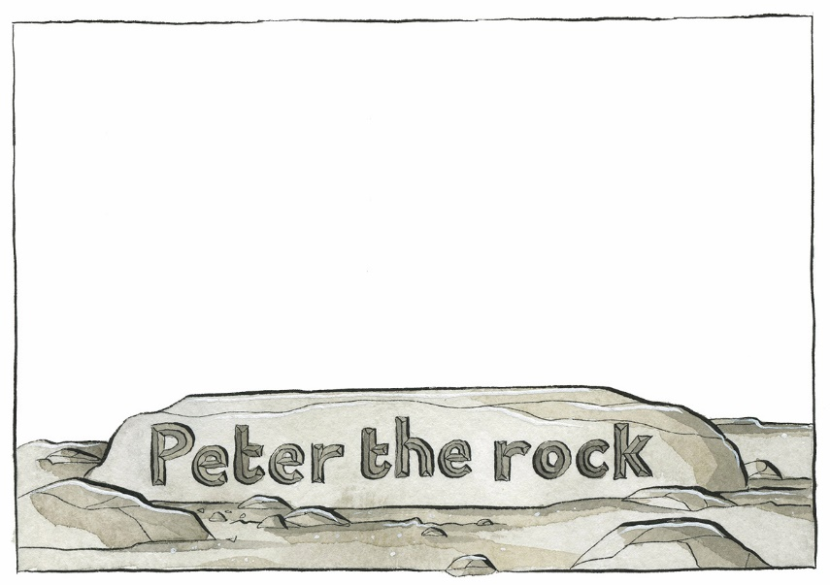
Together, draw simple images, or write key words on the artwork provided.
- As you do so, talk about what it means for you to be a part of the Church.
- Who do we go to for help in our own faith journeys?
- In what ways might this current crisis inspire us to put our trust anew in Jesus rather than physical buildings or earthly expressions of faith?
- How do you want Church to look like in the coming months?

Craft
Decorated rocks
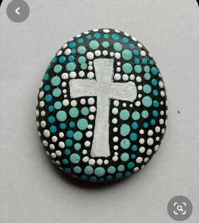
You will need: two small rocks or pebbles; marker or felt tip pens.
Method
- Decorate one rock with the name of Jesus as you reflect upon what it means to build your life on Jesus the rock. Keep the rock somewhere you will see it often as a reminder of the firm foundation you are building your life upon.
- Decorate the other rock or pebble – you could draw a cross, a fish, a heart. Next time you are walking by the church, why not place it on the path that leads to the door?!

Junk Model Church
You will need: an assortment of “junk” items: old tubs, boxes, kitchen rolls, pipe cleaners, foil, coloured paper; glue or sticky tape.
Method:
- Using your “junk” items, create your own church – in whatever design you want! This picture is just one way of doing it. Be as creative as you like! Why not try and make a 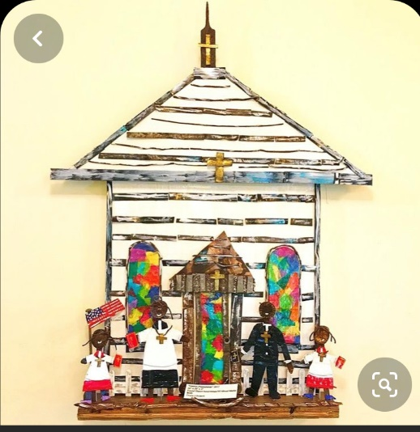 model of St Andrew’s?!
- Use glue or sticky tape to hold it all together! The coloured paper could be used as the stain glassed windows.
- Alternatively, you could make a 3D picture – create a church on paper using pipe cleaners, cardboard, coloured paper for the stained glass windows.
- Don’t forget to send us a photo: curate@standrewstapleford.org

Prayer
Button Prayers
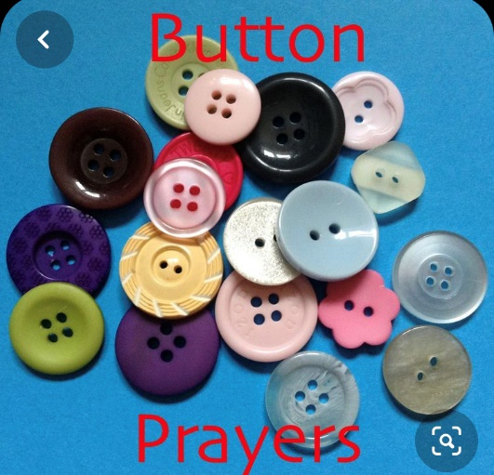
You will need: an assortment of different buttons; coloured paper; glue
Method:
- Pick up a button; think of all those who are going through a hard time. Ask God to help them.
- Buttons are used to fasten clothes together. Ask God to bring together people who have fallen out and moved apart from each other. Pray that He will bring peace.
- Look at your button. See how many holes it has. Think of all the good things in your life and thank God for His blessings.
- Look at the colour of your button and say thank you to God for something of the same colour e.g. green -apple/grass; blue – sky/sea etc!
- Group buttons of the same colour and thank God for families. Ask God to bless them and help them to live together and to love each other.
- Sort the buttons so that you can see their differences. Thank God for making everyone different and for giving us all different gifts
- Glue the buttons into a heart shape on your piece of paper. Thank God for our Church family. Ask God to bless and protect us.

Song: All the way

All the way my saviour leads me.
What have I to ask beside?
Can I doubt his tender mercy?
Who through life has been my guide.

Heavenly peace, divinest comfort.
Here by faith in him to dwell.
For I know whate’er befall me.
Jesus always does all things well.
All that I am, all that I have;
All that I’m going to be.
Giver of life;
Giver of hope;
I owe it all to you.

All that I am, all that I have;
All that I’m going to be.
Giver of life;
Giver of hope;
I owe it all to you.

Sing and listen
He’s Jesus, Vineyard worship
Holy wisdom, lamp of learning, Ruth C. Duck
Who you say I am, Hillsong worship on There is more
God only knows (Timbaland remix), For king & country on God only knows
Written in the skies, Luke & Anna Hellebronth on Motions of mercy
See also Same Boat @ HOME

Activity Sheet English

Colouring Sheet English

