Messy Forest Church activities
December 20 2020
1. Reindeer decorations
You will need: wooden pegs, googly eyes, ribbon, glue
Method:
- create a reindeer decoration with the materials provided and hang on your tree!

2. Shepherds Christmas Stockings
You will need: a small Christmas stocking; stickers; pens
Method:
- Decorate your stocking with the materials provided

3. Mini Christmas forest
You will need: 4 small pieces of wood – flat and round, if possible; a screwdriver to make small holes; a selection of small green branches; glue; fake snow spray. 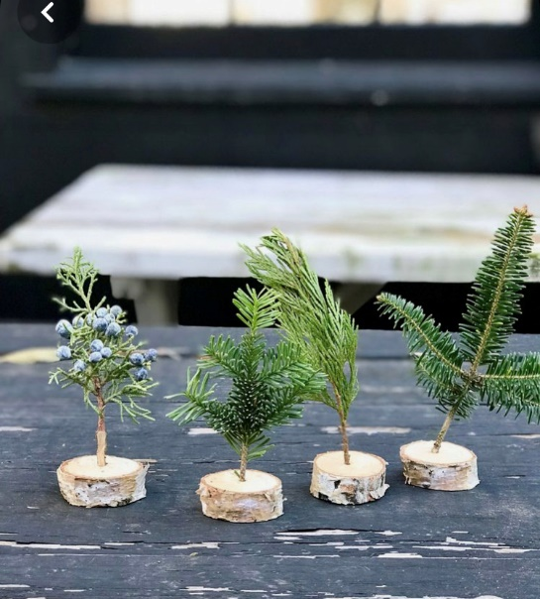
Method:
- Forage for the base piece of wood and the tiny branches;
- With the help of an adult, make a hole with a screwdriver.
- Stick the branches in the holes, using glue to secure if necessary.
- Spray with fake snow!
Prayers: Red ribbon prayers
You will need: lengths of red ribbon
Method:
- Invite each family group to tie a red ribbon prayer to the yew tree, offering our prayers to God in open prayer.
- Conclude by gathering our prayers and offering them to God and in saying the Lord’s prayer

