Being Together
Bible Story Matthew 14:13-21; John 6:1-15
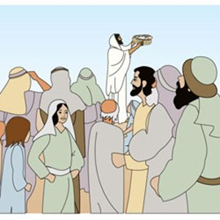

¹³ Jesus… withdrew by boat privately to a solitary place. Hearing of this, the crowds followed him on foot from the towns. ¹⁴ When Jesus landed and saw a large crowd, he had compassion on them and healed their sick.
¹⁵ As evening approached, the disciples came to him and said, “This is a remote place, and it’s already getting late. Send the crowds away, so they can go to the villages and buy themselves some food.”
¹⁶ Jesus replied, “They do not need to go away. You give them something to eat.”
¹⁷ A young boy stepped forward and said: “Sir, I have five loaves of bread and two fish, which my Mum gave me. We can share these.” Jesus smiled.
¹⁸ “Bring them here to me,” he said. ¹⁹ And he directed the people to sit down on the grass. Taking the five loaves and the two fish and looking up to heaven, he gave thanks and broke the loaves. Then he gave them to the disciples, and the disciples gave them to the people. ²⁰ They all ate and were satisfied, and the disciples picked up twelve basketfuls of broken pieces that were left over. ²¹ The number of those who ate was about five thousand men, besides women and children.

Craft
Foil Fish
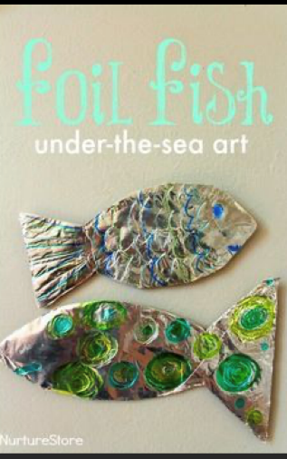
You will need: two pieces of card; scissors; pens; foil; pieces of coloured card or tissue paper; glue.
Method:
- Draw two fish shapes on your card and cut them out.
- Cut foil into small pieces and glue onto the fish so they look like scales; add coloured paper.
- Draw in the eyes and a smile!

Bread rolls

Ingredients
- 500g strong white bread flour, plus extra for dusting
- 7g sachet fast action yeast
- 1 tsp white caster sugar
- 2 tsp fine salt
- 1 tsp sunflower oil
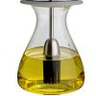
plus extra for the work surface and bowl

Method
- Tip the flour, yeast, sugar, salt and oil into a bowl. Pour over 325ml warm water, then mix (with a spatula or your hand), until it comes together as a shaggy dough. Make sure all the flour has been incorporated. Cover and leave for 10 mins.
- Lightly oil your work surface and tip the dough onto it. Knead the dough for at least 10 mins until it becomes tighter and springy – if you have a stand mixer you can do this with a dough hook for 5 mins. Pull the dough into a ball and put in a clean, oiled bowl. Leave for 1 hr, or until doubled in size.
- Tip the dough onto a lightly floured surface and roll into a long sausage shape. Halve the dough, then divide each half into four pieces, so you have eight equal-sized portions. Roll each into a tight ball and put on a dusted baking tray, leaving some room between each ball for rising. Cover with a damp tea towel and leave in a warm place to prove for 40 mins-1 hr or until almost doubled in size.
- Heat the oven to 230C/210C fan/gas 8. When the dough is ready, dust each ball with a bit more flour. (If you like, you can glaze the rolls with milk or beaten egg, and top with seeds.) Bake for 25-30mins, until light brown and hollow sounding when tapped on the base. Leave to cool on a wire rack.
Recipe from bbcgoodfood.com, March 2020

Prayer: 5 finger prayers

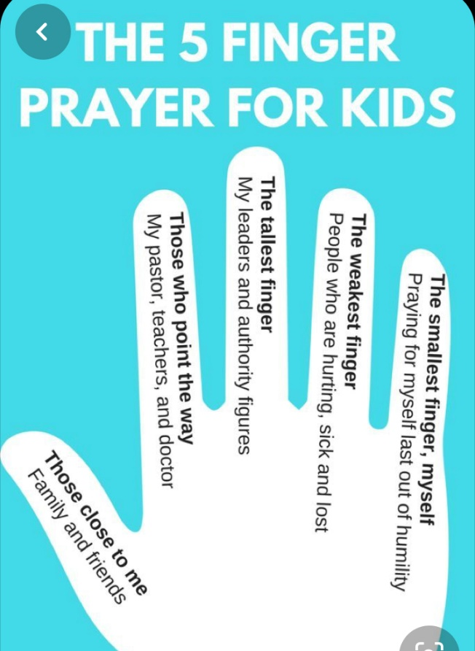

You will need: a piece of paper, pencil, scissors
Method:
- Draw around your hand
- On your thumb, write the names of those close to you. Pray for them.
- On your second finger, write the names of those who point the way. Pray for them.
- On your third finger, write the names of those who are your leaders. Pray for them.
- On your fourth finger, write the names of those who are sick or lonely. Pray for them.
- On your little finger, write your name. Pray for yourself.

Song: Feeding of the 5,000

Gather around for the table is spread,
Welcome the food and rest.
Wide is our circle with Christ at the head,
He is the honoured guest.

Learn of his love, grow in his grace,
Pray for the peace he gives.
Here at this meal, here in this place,
Know that his spirit lives.

Once he was known in the breaking of bread,
Shared with a chosen few.
Multitudes gathered and by him were fed,
So will he feed us too.

Activities Sheet
Childrens_Sheet_05

Songs
See YouTube:

Jesus Feeds the 5,000

Twos: Jesus Feeds 5000 (Song)

And also Same Boat @ HOME

