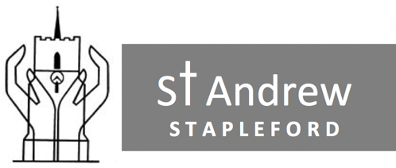
Online Messy Church
15 November 2020

The Lord be with you.
And also with you.
SONG – Guide me O thou Great Redeemer sung by Bobby Coates, accompanied by Harry Coates
BIBLE STORY - 1 Samuel 17:32-50 – read by Alastair McGregor
David said to Saul, “Let no one lose heart on account of this Philistine; your servant will go and fight him.” Saul replied, “You are not able to go out against this Philistine and fight him; you are only a young man, and he has been a warrior from his youth.” But David said to Saul, “… The Lord who rescued me from the paw of the lion and the paw of the bear will rescue me from the hand of this Philistine.” Saul said to David, “Go, and the Lord be with you….” Then Saul dressed David in his own tunic. He put a coat of armour on him and a bronze helmet on his head….“I cannot go in these,” David said to Saul, “because I am not used to them.” So he took them off. Then he took his staff in his hand, chose five smooth stones from the stream, put them in the pouch of his shepherd’s bag and, with his sling in his hand, approached the Philistine. Meanwhile, the Philistine, with his shield bearer in front of him, kept coming closer to David. He looked David over and saw that he was little more than a boy, glowing with health and handsome, and he despised him... “Come here,” he said, “and I’ll give your flesh to the birds and the wild animals!” David said to the Philistine, “You come against me with sword and spear and javelin, but I come against you in the name of the Lord Almighty, the God of the armies of Israel, whom you have defied…. As the Philistine moved closer to attack him, David ran quickly toward the battle line to meet him. Reaching into his bag and taking out a stone, he slung it and struck the Philistine on the forehead. The stone sank into his forehead, and he fell face-down on the ground. So David triumphed.
TALK – Zoe Clayton
ACTIVITIES – for further details see our activities sheet
1. Elephant and Mouse
2. Whirling buzzer
3. Courage Jar
PRAYER Leaves – led by the Walls family
BLESSING
Bless to us Lord,
the earth beneath our feet;
Bless to us Lord,
the path we tread: our walk this day with
the Father, the Son and the Holy Spirit.
May this place be a sacred place,
a telling place where heaven and earth meet.
Amen.
Nocturne in Eb minor, by Frederic Chopin – played by John Bryden

Gifts to support the ministry of the church are most welcome; please gift aid them if you can.
Six ways to give …
- use our card/mobile reader
- text STANDREW 6 to 70085 to donate £6 -
this costs £6 plus a std msg rt, or choose your own £
- scan the QR code →
- cash
- cheque to Stapleford PCC
- through our website standrewstapleford.org/giving

