Forest Church Communion
Sunday November 1 2020
Activities Sheet
CRAFT ACTIVITIES
1. Poppies for Remembrance Sunday SUE
You will need: thin red foam cut to shape; black centre; florist wire
Method:
- Assemble the poppy using materials provided
- Push stem into ground to line the path into Church for Remembrance Sunday

2. Bee Beatitudes
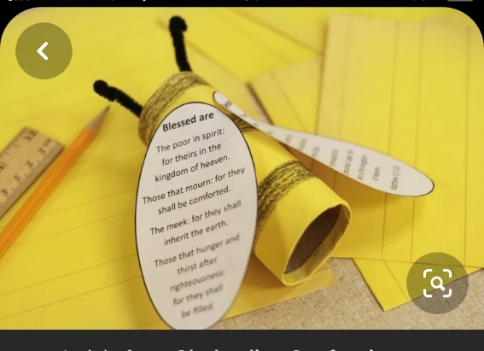
You will need: toilet rolls or kitchen rolls cut in half; yellow and black paper; pipe cleaners; white paper; scissors; pens; sticky tape.
Method
- Cover your tube with yellow paper and colour in black stripes.
- Use black pipe cleaners to add a pair of antennae
- Cut out two wing shapes and write:
- God blesses…the poor; the bereaved; the meek; the hungry and thirsty; the merciful; the pure in heart; peacemakers; the persecuted; the insulted. Rejoice and be glad! God blesses you.

3. Living out the beatitudes
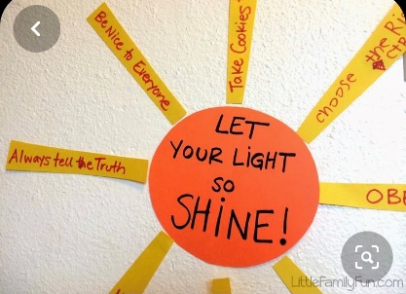
You will need: yellow and orange card; glue; scissors; pens; white paper
Method
- Cut the orange paper into a circle
- Cut the yellow paper into strips
- In the middle of the circle write: Living out the beatitudes
- On the yellow strips write: Be kind; always tell the truth; be a good friend; feed the hungry; share; show compassion; give someone a hug!; reach out; etc
- Stick the circle and strips onto a piece of white paper.

