Messy Church Activities Sheet February 21 2021
1. Cupcake angels
You will need:
- Circles of paper or empty cupcake cases
- Plain paper for the face
- Scissors
- Sticky tape
- Glue stick
- A pen
- Something for the halo, e.g. pipe cleaner, paper clip or paper
Method
- Fold a circle or cupcake case in half and then half again, and secure with sticky tape.
- Fold another circle or cupcake case in half, then half again, then half again and cut two sections out along the fold lines for the wings.
- Tape two sections on the back of the first folded circle.
- Draw a small circle on the plain paper (you could draw round a penny), cut out, draw on a face and then use the glue stick to attach to the angel.
- Make a halo from a piece of pipe cleaner, a paper clip or a piece of paper and attach.
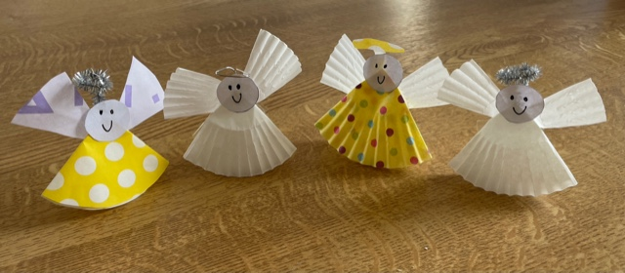

2. Wilderness garden with wild beasts
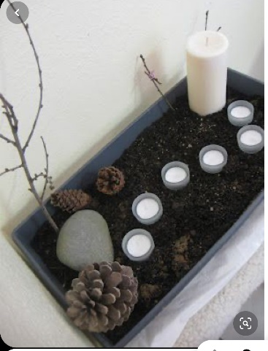
You will need: a shallow, long tray or bowl; soil or sand; stones, a branch, 6 candles, pine cones, plastic or wooden toy animals (the wild beasts!)
Method:
- Fill your tray or bowl with soil or sand.
- Add the stones and pine cones.
- Add the candles.
- Add a large branch. You could hang your cupcake angels to it once you have made it!
- Add the wild beasts and think about how, when Jesus was in the wilderness, he was tended to by wild beasts and angels.
- Light one candle – as a reminder it’s the first Sunday in Lent. Then light a candle for each following Sunday in Lent to show that as we progress through this season, the light of Easter is coming.
3. Holy spirit flame
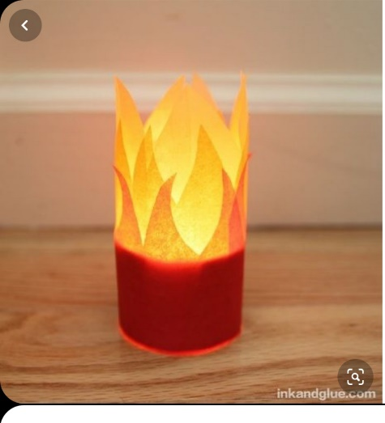
You will need: a glass jar; a tealight candle; red, yellow and orange tissue paper; sticky tape or glue
Method:
- Take a clean jar and decorate it with the tissue paper
- Add the candle and with the help of an adult light it
- As you watch the flame, remember that the Holy Spirit guided Jesus in the wilderness, and is with us too, everyday
PRAYERS A washing Prayer
You will need: two bowls, one filled with soil, the other with water; play figures
Method:
- Bury the play figures in the soil. Make sure the dirt sticks to them
- Then wash each one in the bowl of water
- Prayer focus: think about being made ready by God for the day ahead, week ahead, Lent etc finishing with We know you love us God and that we are your children. Make us ready for the things you want us to do. Amen
- Other prayers
- Finish with the Lord’s prayer

